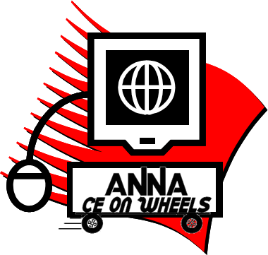**CE on Wheels Request Form**

**Interested in Hosting a CE on Wheels Program?**

Submit form to [arhlene.delfin@annanurse.org](mailto:arhlene.delfin@annanurse.org) to receive an access code and instructions for your selected session(s).

**Chapter Name:**       **Chapter #:**

**Contact Name:**       **Program** **Date:**        **Daytime Phone Number:**       **Email:**

**Step One**: Select a session:

***Nephrology Nurses and Empathy:  The Impact on Older Adults Experiencing Loss and Grief*** *(Exp 9/18/2026)* **1.25 CH**

***Empowering Organ Donation: Unlocking Pathways to Expand the Kidney Donor Pool*** *(Exp 9/18/2026)* **1.25 CH**

***Building Patient Trust: Steps to Improve ICH CAHPS*** *(Exp 9/18/2026)* **1.25 CH**

***Supplementing Your Knowledge: Non-Prescription and Natural Products in Nephrology*** *(Exp 9/18/2026)* **1.25 CH**

**Step Two:** What type of meeting will you provide?

Live, in-person Location (City, State)

In-person meetings require a computer, LCD, audio speakers, and a screen large enough for your audience.

Virtual

Use your own video service (Zoom, Teams, etc.) to view the presentation.

**Step Three:** Advertise and promote your meeting! A session flyer will be included with your program materials.

**Step Four:** Watch the program!

**Step Five:** Earn NCPD by completing the session evaluation in the Online Library.

**Questions?**

**Contact Arhlene Delfin**

**856-256-2316**

[**arhlene.delfin@annanurse.org**](mailto:arhlene.delfin@annanurse.org)

***Note: Sessions are FREE for ANNA members and $10 for non-members.***