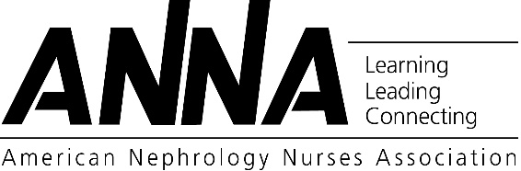

Scholarship Applicant

Recommendation Form

|  |  |  |  |  |  |  |  |
| --- | --- | --- | --- | --- | --- | --- | --- |
| Applicant’s Name: |  | | | | | | |
| **Applicant: Please Mail or Give This Form to Your Recommender to Complete** | | | | | | | |
| Recommender’s Name: | |  | | Recommender’s Position/Title: |  | | |
| Recommender’s Phone: | |  | | Recommender’s  E-mail: |  | | |
| **Signature of Recommender:** | | |  | | | **Date:** |  |
|  | | | | | | | |

|  |  |  |  |  |  |  |  |
| --- | --- | --- | --- | --- | --- | --- | --- |
| **This Portion is to be Completed by the Recommender** | | | | | | | |
| To the Recommender: We would appreciate your opinion of the above applicant for ANNA scholarship(s) to pursue a BSN or advanced degree in nursing. | | | | | | | |
| We are particularly interested in an evaluation of the applicant’s potential for academic and professional achievement in the field indicated. **Please do not use applicant’s name in your written comments**, as this form must be blinded for review. Forms must be received on or before **October 15, 2019**. | | | | | | | |
|  | | | | | | | |
|  | Excellent | Above Average | | Average | Below Average | Poor | No basis for judgment |
| Intellectual ability |  |  | |  |  |  |  |
| Imagination & creativity |  |  | |  |  |  |  |
| Verbal communication skills |  |  | |  |  |  |  |
| Writing ability |  |  | |  |  |  |  |
| Quality of work |  |  | |  |  |  |  |
| Nephrology nursing practice |  |  | |  |  |  |  |
|  | | | | | | | |
| Additional comments regarding character, integrity, or motivation are appreciated if pertinent. Limit typed comments to space below. **DO NOT** include applicants name in your comments. *Write “the applicant” instead of applicant’s name or he/she, him/her.* | | | | | | | |
|  | | | | | | | |
| How long have you known this Applicant? | | |  | | | | |
| In what capacity have you known this Applicant? | | |  | | | | |
|  | | | | | | | |

**Recommendation forms attached to the application or e-mailed by the Applicant will NOT be reviewed!**

**Recommender- Please Email this completed form to:**

Paula Richards, Awards & Scholarships Chairperson

c/o Linda Hanford– linda.hanford@annanurse.org

*Please include the applicant’s name in the subject line.*

j0426084

**Must Be Received By – October 15, 2019**