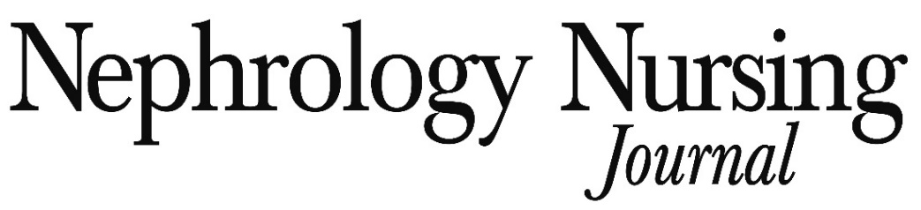

2023 Space Reservation Form

YES, we want to reach the nephrology nursing market while supporting the activities of the American Nephrology Nurses Association. Please reserve our advertising space in Nephrology Nursing Journal as follows: We understand that this contract will serve as our insertion order. We will pick-up current advertising materials unless notified by the respective closing dates (listed below).

2023 ISSUE |  | AD SIZE | COLOR  (BW or 4C) | COST
 | January/February  Closing Date – January 3, 2023 | Pre-Symposium Issue; NCPD Articles
 | March/April  Closing Date – March 1, 2023 | Electronic Edition Available to All Attendees at ANNA’s  2023 National Symposium (May 7-10, 2023); NCPD Articles
 | May/June  Closing Date – May 1, 2023 | Post Symposium Issue: NCPD Articles
 | July/August  Closing Date – June 30, 2023 | Pre-Nephrology Nursing Practice, Management & Leadership Conference Issue; NCPD Articles
 | September/October  Closing Date – August 21, 2023 | Electronic Edition Available to All Attendees at ANNA’s  2023 Fall Conference (October 14-16, 2023); NCPD Articles
 | November/December  Closing Date – November 1, 2023 | Annual Index of Articles; NCPD Articles

PLEASE INVOICE AS FOLLOWS: Bill Us Directly Bill Our Advertising Agency

Advertiser
Address
City |  | State |  | Zip Code
Telephone | Fax |  | Email
Authorized By |  | Title
IF AGENCY IS TO BE BILLED, COMPLETE THE FOLLOWING:
Agency
Address
City |  | State |  | Zip Code
Telephone | Fax |  | Email
Authorized By |  | Title

Send completed contract to Nephrology Nursing Journal, c/o Anthony J. Jannetti, Inc., East Holly Avenue, Box 56, Pitman, NJ 08071-0056 or via email to susan.iannelli@annanurse.org. If you have any questions or wish to reserve space by phone, please call Susan Iannelli, Marketing Manager, at 856-256-2376.

