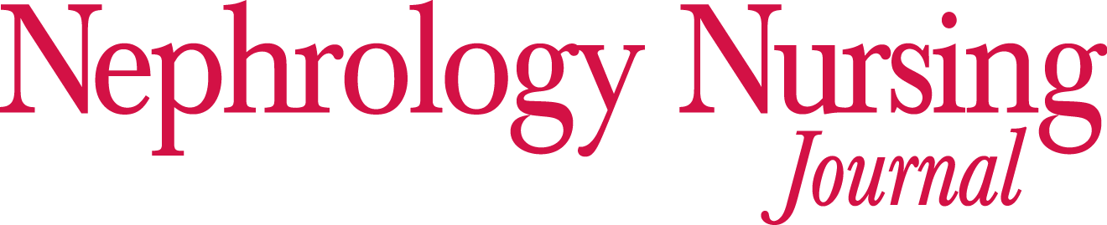
Permission Form - Image and Professional Release

Please read carefully, as not every section may be relevant to your image.

Section I. – Release of Image

I, _______________________________________ (signee), being of legal age, hereby consent and authorize American Nephrology Nurses Association (ANNA) to use and reproduce name(s), slide(s), and/or photograph(s) of my image, and circulate the same for any and all ANNA purposes, including the Nephrology Nursing Journal and ANNA publications of every description.

Section II. - Release of a Minor’s (Under Eighteen Years of Age) Image:

I, _______________________________________ (signee), being of legal age, hereby consent and authorize American Nephrology Nurses Association (ANNA) to use and reproduce name(s), slide(s), and/or photograph(s) of the above named minor’s image, and circulate the same for any and all ANNA purposes, including the Nephrology Nursing Journal and ANNA publications of every description.

Section III. – Professional Release of Use

I, _______________________________________ (photographer), being of legal age, hereby consent and authorize American Nephrology Nurses Association (ANNA) to use and reproduce my photograph(s) of the above named signee, or the above named minor, and circulate the same for any and all ANNA purposes, including the Nephrology Nursing Journal and ANNA publications of every description.

Receipt of full consideration is hereby acknowledged, and no further claim of whatsoever nature arising out of or connected with said name(s) and photograph(s), will be made by me, or by my heirs, or assigns.

Today’s Date:
Name of Signee:
Address of Signee:
Name of Photographer:
Photographer’s Institution:

PERMISSION IS HEREBY GRANTED:
Print Name and Credentials | Signature (Electronic signature is acceptable) | Date

