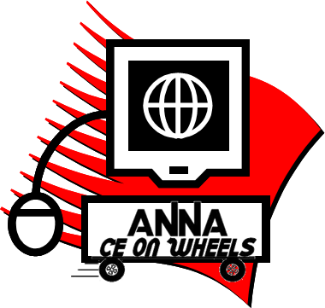
CE on Wheels Request Form
Interested in Hosting a CE on Wheels Program?

Submit form to jennifer.carroll@annanurse.org to receive an access code and instructions for your selected session(s).

Chapter Name: Chapter #:
Contact Name: Program Date:
Daytime Phone Number: Email:

Step One: Select a session:

Focusing on Mental Health Across the Lifespan (Exp 10/3/2024) 1.25 CH/1.25 Rx
Evaluation of Patient Frailty and Implications for Care (Exp 10/3/2024) 1.25 CH
Keys to Developing Successful Nephrology Nurse Careers (Exp 5/10/2025) 1.00 CH
Conflict Resolution in the Nephrology Profession (Exp 5/10/2025) 1.25 CH

Step Two: What type of meeting will you provide?

Live, in-person Location (City, State)
In-person meetings require a computer, LCD, audio speakers, and a screen large enough for your audience.

Virtual
Use your own video service (Zoom, Teams, etc.) to view the presentation.

Step Three: Advertise and promote your meeting! A session flyer will be included with your program materials.

Step Four: Watch the program!

Step Five: Earn NCPD by completing the session evaluation in the Online Library.

Questions?
Contact Jennifer Carroll
856-256-2348
jennifer.carroll@annanurse.org
Note: Sessions are FREE for ANNA members and $10 for non-members.

